Borehole No. Exploration Borehole No 1
Location Samanhyia, Afram Plains
Latitude N 06°59.991’
Longitude W00°09.868’
Date started 28/04/2001
Date completed 29/04/2001
Altitude about 530 ft (161.5m) – about 280ft (85.3m) above lake level

Summary Lithological Log
Depth(m)
From To

0 2 Soil/very weathered conglomerate

2 8.1 Very weathered conglomerate with clay
8.1 15.2 Weathered gravely conglomerate

15.2 21.3 Weathered medium to coarse grained sandstones, some gravel
21.3 24.4 Weathered coarse-grained sandstone and gravel
24.4 28.5 Weathered medium grained sandstone
28.5 46.7 Weathered medium to fine grained sandstone, some gravel
46.7 49.8 Weathered shaley fine-grained sandstone
49.8 52.8 Weathered medium to fine grained sandstone
52.8 53.9 Silty mudstone
53.9 58.9 Fairly weathered medium to fine grained sandstone
58.9 90.4 Medium to fine grained sandstone with odd gravel and pebble bands
90.4 96.2 Medium to fine grained sandstone
96.2 105.7 Medium to fine grained sandstones with coarse grained sandstone and
gravel
105.7 112.8 Medium to fine grained sandstone with some gravels
112.8 117.9 Medium to fine grained sandstone
117.9 121.9 Medium to fine grained sandstone with quartz veining

Comments on Water Production Zones
First water struck with small amount (42 l/min) at base of weathered gravel at 24m
Additional water produced from fairly weathered sandstone at base of weathered zone between 54-62m (flow increased incrementally from 75 to 240 l/min across this zone)
Additional small inflows from gravels at 82-86m and 97-99m maintained flow at 240 l/min
Well-defined fracture zone between 118-121m produced a substantial inflow of water (flow increased to 400 l/min)
Smearing of the borehole wall by fine grained sands within the weathered zone and clays produced by the drilling of shales from 49-49m reduced water inflow.
The water inflow zones at 24m, 54-62m 82-86m and 97-99m would need to be jetted with air prior to well construction. There was little evidence of fracturing except between 118-121m. Water inflow above that level seems to occur from weathered zones and coarser layers at depth. The small inflows below 82m and the main inflow at 118-121m could be fed by lake water this being at a level of some 85m below ground level at Samanshiya

Detailed Lithological Log

Depth(m)
From To

Soil/very weathered conglomerate
0 1 Very weathered conglomerate, grey quartzose pebbles weathered red,
ferruginous yellow, with brown orange silty fine sand matrix
1 2 Fragments of polymict conglomerate, mainly grey, white and pink with some
yellow and brown mainly quartzose clasts. Sandy matrix, clayey in parts

Very weathered conglomerate with clay
2 3.1 Very weathered conglomerate, smaller clasts, mainly quartz,with orange pink
and white sandy, silty clay matrix
3.1 4.1 Very weathered conglomerate with quartzose and feldspathic clast
fragments. Some light brown to white silty clay matrix
4.1 5.1 Weathered conglomerate with mainly dark red, green bright orange and grey
quartzose clasts. Some fragments of medium to coarse hard sandstone
5.1 6.1 About 50%fragments of quartzose clasts and 50% interbedded platey
red brown fairly soft to fairly hard medium sandstone
6.1 7.1 Mainly green and red clast fragments, the green and white/green are silcrete
or silcretised pebbles. Some red brown fragments of very hard silcretised
medium sandstone, also some white quartz fragments
7.1 8.1 Very weathered rounded gravel with brown black sandy matrix, most gravels
are orange brown, black or white silcretised sediments or quartz

Weathered gravely conglomerate
8.1 9.1 Gravel of black, red, orange and white mainly quartz fragments with some
red brown medium grained sandstone
9.1 10.2 Orange red and white coarse sand and gravel composed of white and black
quartz and orange red medium to coarse grained fairly hard sandstone with
some greenish yellow chloritic fragments
10.2 11.2 Mainly orange red, dark grey and white quartzitic fragments. Red brown
rounded gravels, grey fine grained hard sandstones and red white and grey
quartzitic fragments, some greenish yellow chloritic fragments
11.2 12.2 Orange and dark grey fragments some white, orange and white mainly
quartz – crystalline, grey fine grained hard sandstone, some greenish
yellow chloritic fragments
12.2 13.2 Grey white and orange gravel, orange and white fragments of
crystalline quartz, grey fragments of hard silcretised fine to medium
sandstone, with odd greenish yellow chloritc fragment
13.2 14.2 Mainly orange grey and some white rounded to subrounded small
pebbles to coarse gravel mainly of quartz, some greenish yellow
fragments
14.2 15.2 Mainly orange grey and some white quartz and purple brown sandstone
rounded to subrounded small pebbles to coarse gravel, some siliceous fine
grained sandstone and odd greenish yellow fragments

Weathered medium to coarse grained sandstones, some gravel
15.2 16.3 40% fragments of orange grey and white quartz gravel, 60% fragments
light grey and orange medium to coarse sandstone
16.3 17.3 Light grey and orange fairly soft medium to coarse grained sandstone
with some greenish yellow chloritic fragments
17.3 18.3 Light grey and orange soft medium sandstone
18.3 19.3 Light grey and orange very soft medium to coarse sandstone
19.3 20.3 Light grey and orange soft coarse to medium sandstone some greenish
yellow chloritic fragments, light grey silty matrix
20.3 21.3 Light grey and orange soft medium sandstone with grey fine grained matrix

Weathered coarse grained sandstone and gravel
21.3 22.4 Light grey and orange coarse sandstone with gravel with fragments of
yellow and white quartz, some grey clay
22.4 23.4 Light grey and orange coarse to medium sandstone and orange white
and grey mainly quartzose gravel
23.4 24.4 White orange and grey quartzose coarse sand and gravel with hard
orange light grey medium grained sandstone

Weathered medium grained sandstone
24.4 25.4 Light grey and orange soft medium to coarse sandstone, grains mainly
white and orange quartz with light grey matrix (FRACTURE – 42 L/MIN)
25.4 26.4 Orange grey fairly hard medium grained sandstone
26.4 27.4 Light grey to orange fairly soft medium grained sandstone, more
orange than grey
27.4 28.5 Light grey and some orange soft medium to fine sandstone
28.5 29.5 Light grey and some orange soft medium to fine sandstone

Weathered medium to fine grained sandstone, some gravel
29.5 30.5 10R3/2 dusky red fine to medium soft sandstone, some light blue grey
mottles
30.5 31.5 Dusky red fairly soft fine to medium sandstone (Flow – 35 l/min)
31.5 32.5 Dusky red fairly soft fine to medium sandstone
32.5 33.5 Dusky red fairly soft fine to medium sandstone with some thin grey
bands
33.5 34.5 Dusky red fairly soft fine to medium sandstone, some thin grey bands
and some white orange quartz gravel
34.5 35.6 Dusky red fairly soft to fairly hard platey fine to medium grained
sandstone
35.6 36.6 Dusky red fairly soft fine to medium grained sandstone
36.6 37.6 Dusky red fairly soft fine to medium grained sandstone, larger
fragments (Flow – 24 l/min)
37.6 38.6 Dusky red fairly soft fine to medium grained sandstone, with quartzose
gravel fragments
38.6 39.6 Dusky red fairly soft to hard fine to medium grained sandstone
39.6 40.6 Dusky red fairly soft fine to medium grained sandstone with grey and
brown fine grained quartzose gravels
40.6 41.7 Dusky red fairly hard medium to fine grained sandstone
41.7 42.7 Dusky red fairly soft medium to fine grained sandstone
42.7 43.7 Dusky red fairly soft medium to fine grained sandstone with odd
gravel fragment (Flow – 24 l/min)
43.7 44.7 Dusky red fairly soft medium to fine grained sandstone with light blue
grey layer
44.7 45.7 Dusky red medium to coarse soft sandstone with fine sand matrix,
some brown and white quartz gravels
45.7 46.7 Dusky red soft medium to fine sandstone with very hard shaley fine
sandstone, some quartz gravel

Weathered shaley fine grained sandstone
46.7 47.8 Hard dark brown shaley fine grained sandstone with bands of soft
medium to fine grained sandstone and thin bands of light blue grey
sandstone
47.8 48.8 Hard dark brown platey fine grained sandstone with softer shaley
interbeds
48.8 49.8 Dark red brown hard silty fine grained sand, platey fragments, with
soft interbedded clayey silty mudstones (Flow – 16 l/min)

Weathered medium to fine sandstone
49.8 50.8 Dusky red medium to coarse grained soft sandstone, some gravel
50.8 51.8 Dusky red soft medium to fine grained sandstone
51.8 52.8 Dusky red soft silty fine to medium grained sandstone

Silty mudstone
52.8 53.9 Mottled dark red brown and light grey silty mudstones

Fairly weathered medium to fine grained sandstone
53.9 54.9 Dark red brown medium to fine soft sandstones above very hard light
grey orange medium to fine grained sandstone (FRACTURE – 52 L/MIN)
54.9 55.9 Soft dark red brown medium to fine grained sandstone and silty fine
grained sandstone with odd light grey mottles
55.9 56.9 Dark red brown fairly soft medium to fine sandstone
56.9 57.9 Dark red brown fairly soft to fairly hard medium to fine grained
sandstone
57.9 58.9 Dark brown fairly soft platey friable medium to fine grained sandstone

Medium to fine grained sandstone with odd gravel and pebble bands
58.9 59.9 Mottled dark red brown and blue grey fairly soft medium to fine
grained sandstone
59.9 61 Mottled blue grey and dark red brown fairly soft to fairly hard medium
to fine grained sandstone with some coarse sand grains (FRACTURE – 75
L/MIN)
61 62 Mottled red brown and blue grey fairly soft to fairly hard medium to
fine grained sandstone
62 63 Mottled red brown and blue grey fairly soft to fairly hard medium to
fine grained sandstone (FRACTURE – 240 L/MIN)
63 64 Mottled red brown and blue grey fairly soft to fairly hard medium to
fine grained sandstone
64 65 Mottled red brown and blue grey fairly soft to fairly hard medium to
fine grained sandstone
65 66 Mottled red brown and blue grey fairly soft to fairly hard medium to
fine grained sandstone
66 67.1 Mottled red brown and blue grey fairly soft to fairly hard medium to
fine grained sandstone (Flow – 200 l/min)
67.1 68.1 Mottled red brown and blue grey fairly soft to fairly hard medium to
fine grained sandstone, with some yellow and grey rounded gravels
68.1 69.1 Mottled red brown and blue grey fairly soft medium to fine grained
sandstone
69.1 70.1 Mottled dark red brown and grey fairly soft to fairly hard medium to
fine grained sandstone, some coarse sand granules
70.1 71.1 Mottled dark red brown and dark grey brown fairly soft medium to fine
grained sandstone
71.1 72.2 Mottled dark red brown and dark blue grey fairly soft to fairly hard
medium to fine grained sandstone
72.2 73.2 Mottled dark red brown and dark blue grey fairly soft to fairly hard
medium to fine grained sandstone
73.2 74.2 Mottled dark red brown and dark blue grey fairly soft to fairly hard
medium to fine grained sandstone with fragments of orange yellow
quartzose pebbles (Flow – 200 l/min)
74.2 75.2 Mottled dark red brown and dark grey fairly soft to hard medium to
fine grained sandstone, odd weathered orange pebble fragment
75.2 76.2 Mottled dark red brown and dark grey fairly soft medium to fine
grained sandstone with some coarse sand granules and odd orange
yellow and white quartz pebble fragment
76.2 77.2 Mottled mainly dark red brown and some bands of dark grey fairly soft
to hard medium to fine grained sandstone
77.2 78.2 Mottled mainly dark red brown and some bands of dark grey fairly soft
to hard medium to fine grained sandstone, with rounded yellow
quartzose coarse gravels
78.2 79.3 Mottled mainly dark red brown and some bands of dark grey fairly soft
to hard medium to fine grained sandstone, with rounded yellow
quartzose coarse gravels (Flow – 200 l/min)
79.3 80.3 Mottled dark red brown and dark blue grey soft to hard silty medium to
fine grained sandstone
80.3 81.3 Mottled dark red brown fairly soft medium to fine grained sandstone
with blue grey shaley siltstone to fine grained sandstone, odd reddened
quartz gravel
81.3 82.3 Dark red brown and grey hard to fairly soft medium to fine grained
sandstone, with yellow orange gravel
82.3 83.3 Mottled dark brown and grey fairly soft medium to fine grained
sandstone, odd yellow white rounded gravel
83.3 84.3 Mottled dark red brown and grey fairly hard to fairly soft medium to
fine grained sandstone, some yellow gravel
84.3 85.3 Mottled dark red brown and grey fairly soft medium to fine grained
sandstone
85.3 86.4 Mottled dark red brown and grey fairly soft medium to fine grained
sandstone (Flow - 240 l/min)
86.4 87.4 Mainly dark red brown with some grey fairly soft to fairly hard
medium to fine grained sandstone
87.4 88.4 Mottled dark red brown and grey fairly hard to fairly soft medium to
fine grained sandstone
88.4 89.4 Mottled dark red brown and grey fairly hard to fairly soft medium to
fine grained sandstone
89.4 90.4 Mottled dark red brown and grey fairly hard to fairly soft medium to
fine grained sandstone

Medium to fine grained sandstones
90.4 91.4 Dark red brown hard medium to fine grained sandstone some blue grey
sandstone layers
91.4 92.5 Mottled dark red brown and blue grey fairly soft to fairly hard medium
to fine grained sandstone (Flow – 200 l/min)
92.5 93.5 Mottled dark red brown and blue grey fairly soft to fairly hard medium
to fine grained sandstone
93.5 94.5 Mottled dark red brown and some blue grey medium to fine grained
fairly hard to soft sandstone
94.5 95.5 Mottled dark red brown and some blue grey medium to fine grained
fairly hard to soft sandstone
95.5 96.5 Mottled dark red brown and some blue grey medium to fine grained
fairly hard to soft sandstone

Medium to fine grained sandstones with coarse grained sandstone and gravels
96.5 97.5 Mottled dark brown grey fairly soft to fairly hard medium to fine
grained sandstone
97.5 98.6 Dark brown medium to fine grained fairly soft friable sandstone, some
coarse sand granules and grey mottles. Odd subrounded orange white
quartz pebble fragments (Flow - 240 l/min)
98.6 99.6 Mottled dark red brown and grey fairly soft to fairly hard medium to
fine grained sandstone, some coarse sand grains and red quartz gravel
fragments
99.6 100.6 Mottled brown and grey fairly soft medium to fine grained sandstone
some coarse sand grains
100.6 101.6 Mottled grey and dark red brown fairly soft to fairly hard medium to
fine grained sandstone with some hard bands and coarse sand granules
101.6 102.6 Mottled dark red brown and grey fairly soft to fairly hard medium to
fine grained sandstone, some patches of hard shale, some coarse sand
granules and yellow brown gravel clasts
102.6 103.6 Dark red brown fairly soft to fairly hard medium to fine sandstone with
grey patches, some coarse sand grains
103.6 104.7 Dark brown with orange grains and grey patches fairly soft to fairly
hard medium to fine grained sandstone (Flow – 240 l/min)
104.7 105.7 Dark brown with orange grains and grey patches fairly soft to fairly
hard medium to fine grained sandstone

Medium to fine grained sandstone with some gravels
105.7 106.7 Dark brown fairly soft medium to fine grained sandstone with few grey
patches
106.7 107.7 Dark brown fairly soft medium to fine sandstone
107.7 108.7 Dark brown fairly soft medium to fine sandstone with some red to dark
red quartzose rounded fine gravels
108.7 109.7 Dark brown fairly soft to fairly hard medium to fine grained sandstone,
some yellow, grey and white quartz gravel fragments
109.7 110.7 Dark brown fairly soft to fairly hard medium to fine grained sandstone,
some grey black quartz gravel fragments (Flow – 240 l/min)
110.7 111.8 Dark brown medium to fine grained friable fairly hard sandstone
111.8 112.8 Dark brown medium to fine grained fairly soft to fairly hard sandstone

Medium to fine grained sandstones
112.8 113.8 Mainly grey with some dark brown medium to fine grained fairly soft
to fairly hard sandstone
113.8 114.8 Hard grey and some fairly soft dark red brown medium to fine grained
sandstone
114.8 115.8 Grey and red brown fairly soft to hard medium to fine sandstone with
some red brown shaley siltstone
115.8 116.8 Grey hard to fairly hard medium to fine grained sandstone, some
coarse sand granules, mainly orange (Flow – 240 l/min)
116.8 117.9 Hard grey orange and fairly soft dark brown medium to fine grained
sandstones, 80%grey and 20% brown - mottled

Medium to fine grained sandstone with some quartz veining
117.9 118.9 Hard dark brown and subordinate dark brownish grey medium to fine
grained sandstone some white vein quartz (FRACTURE – 400 L/MIN)
118.9 119.9 Very hard dark brown medium to fine grained sandstone with some
fairly soft shaley layers, odd grey brown patches and white vein quartz
119.9 120.9 Mottled dark brown and brownish grey fairly hard to fairly soft
medium to fine grained sandstone with some white vein quartz and odd
green white quartz pebble fragment
120.9 121.9 Hard dark grey and orange medium to fine grained sandstone
(Flow – 400 l/min)

Ghana |  | Test pumping |  |  | Point above GL |  |  | 0.8 | M
Borehole No. |  | TH001 |  |  | Pump depth |  |  | 100 | M
Village |  | Samanhiya |  |  | SWL |  |  | 3.58 | M
Date |  | 03/05/2001 |  |  | Start Time |  |  | 06:00
Drawdown test |  |  |  |  | Recovery test
t (mins) | wl (m) | s (m) | q (l/min) | Sp cap | t | t' | t/t' | wl (m) | s' (m)
0 | 3.58 | 0 |  |  | 480 | 0 |  | 38.9 | 35.32
1 | 5.64 | 2.06 | 333 | 161.65 | 481 | 1 | 481.00 | 36.04 | 32.46
2 | 6.51 | 2.93 | 333 | 113.65 | 482 | 2 | 241.00 | 34.9 | 31.32
3 | 7.19 | 3.61 | 333 | 92.24 | 483 | 3 | 161.00 | 33.83 | 30.25
4 | 7.76 | 4.18 | 333 | 79.67 | 484 | 4 | 121.00 | 32.8 | 29.22
5 | 8.28 | 4.7 | 333 | 70.85 | 485 | 5 | 97.00 | 31.85 | 28.27
6 | 8.74 | 5.16 | 333 | 64.53 | 486 | 6 | 81.00 | 30.29 | 26.71
7 | 9.19 | 5.61 | 333 | 59.36 | 487 | 7 | 69.57 | 29.85 | 26.27
8 | 9.58 | 6 | 333 | 55.50 | 488 | 8 | 61.00 | 29.02 | 25.44
9 | 9.95 | 6.37 | 333 | 52.28 | 489 | 9 | 54.33 | 28.05 | 24.47
10 | 10.3 | 6.72 | 333 | 49.55 | 490 | 10 | 49.00 | 27.04 | 23.46
15 | 11.82 | 8.24 | 333 | 40.41 | 495 | 15 | 33.00 | 25.23 | 21.65
20 | 13.04 | 9.46 | 333 | 35.20 | 500 | 20 | 25.00 | 23.27 | 19.69
25 | 14.09 | 10.51 | 333 | 31.68 | 505 | 25 | 20.20 | 22.01 | 18.43
30 | 15.03 | 11.45 | 333 | 29.08 | 510 | 30 | 17.00 | 21.12 | 17.54
35 | 15.85 | 12.27 | 333 | 27.14 | 515 | 35 | 14.71 | 20.37 | 16.79
40 | 16.66 | 13.08 | 333 | 25.46 | 520 | 40 | 13.00 | 19.73 | 16.15
45 | 17.33 | 13.75 | 333 | 24.22 | 525 | 45 | 11.67 | 19.29 | 15.71
50 | 18.05 | 14.47 | 333 | 23.01 | 530 | 50 | 10.60 | 18.75 | 15.17
55 | 18.28 | 14.7 | 333 | 22.65 | 535 | 55 | 9.73 | 18.3 | 14.72
60 | 19.23 | 15.65 | 333 | 21.28 | 540 | 60 | 9.00 | 17.9 | 14.32
75 | 20.7 | 17.12 | 333 | 19.45 | 555 | 75 | 7.40 | 16.85 | 13.27
90 | 21.95 | 18.37 | 333 | 18.13 | 570 | 90 | 6.33 | 15.9 | 12.32
105 | 23.1 | 19.52 | 333 | 17.06 | 585 | 105 | 5.57 | 14.42 | 10.84
120 | 24.13 | 20.55 | 333 | 16.20 | 600 | 120 | 5.00 | 13.73 | 10.15
135 | 25.35 | 21.77 | 333 | 15.30 | 615 | 135 | 4.56 | 13.4 | 9.82
150 | 26.55 | 22.97 | 333 | 14.50 | 630 | 150 | 4.20 | 13.14 | 9.56
165 | 27.77 | 24.19 | 333 | 13.77 | 645 | 165 | 3.91 | 12.62 | 9.04
180 | 29.22 | 25.64 | 333 | 12.99 | 660 | 180 | 3.67 | 12.15 | 8.57
195 | 30.06 | 26.48 | 333 | 12.58 | 690 | 210 | 3.29 | 11.37 | 7.79
210 | 31.12 | 27.54 | 333 | 12.09 | 720 | 240 | 3.00 | 10.72 | 7.14
225 | 32.1 | 28.52 | 333 | 11.68
240 | 32.9 | 29.32 | 333 | 11.36
255 | 33.5 | 29.92 | 333 | 11.13
270 | 33.76 | 30.18 | 333 | 11.03
285 | 34.67 | 31.09 | 333 | 10.71
300 | 35.21 | 31.63 | 333 | 10.53
315 | 35.82 | 32.24 | 333 | 10.33
330 | 36.23 | 32.65 | 333 | 10.20
345 | 36.6 | 33.02 | 333 | 10.08
360 | 37.02 | 33.44 | 333 | 9.96
390 | 37.63 | 34.05 | 333 | 9.78
420 | 38.1 | 34.52 | 333 | 9.65
450 | 38.54 | 34.96 | 333 | 9.53
480 | 38.9 | 35.32 | 333 | 9.43

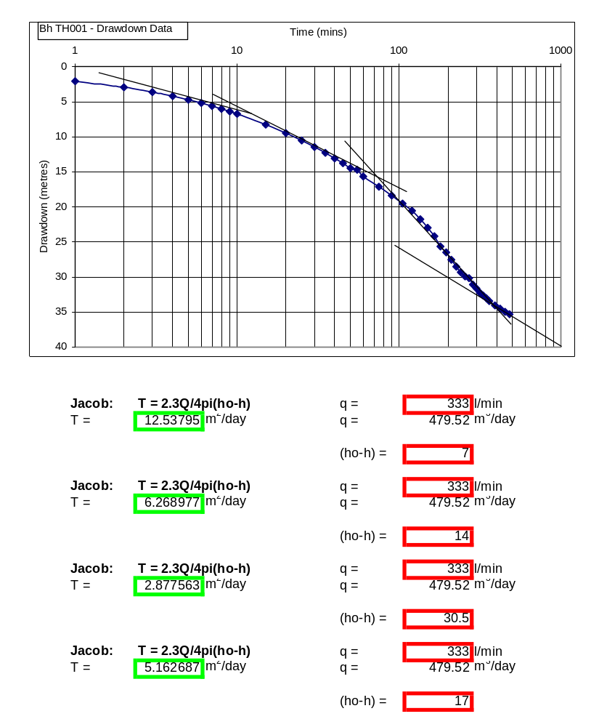

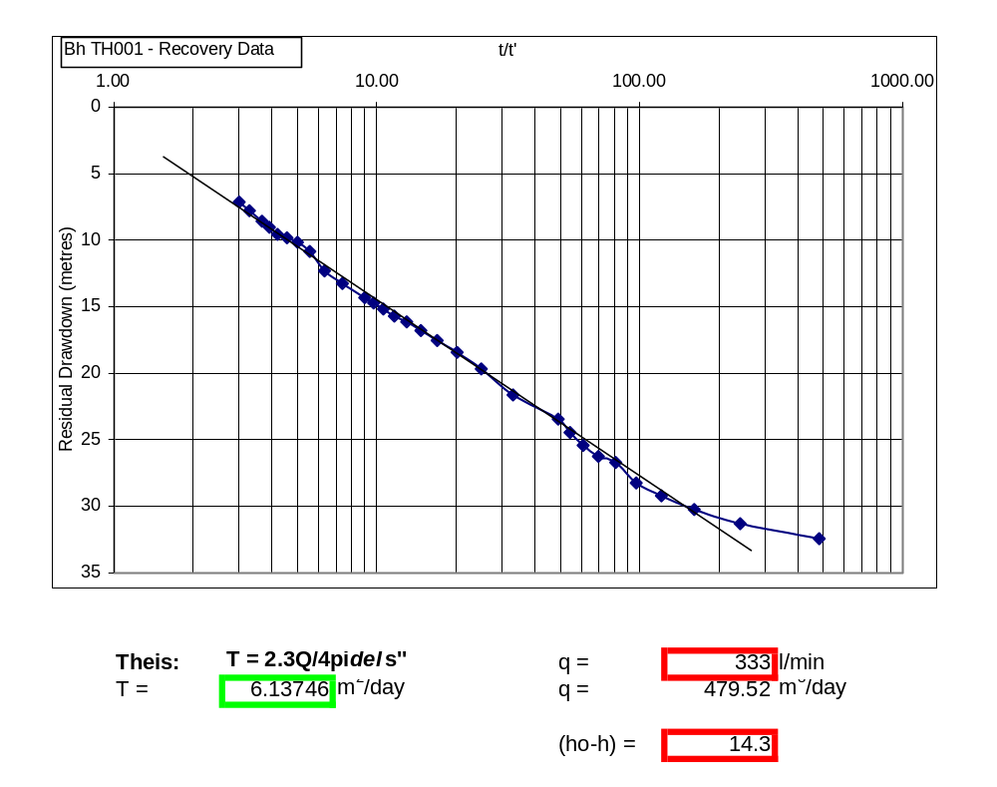

OBSERVATION BOREHOLE |  |  |  |  | Distance from Bh |  | 8.6 | m
Village |  | Samanhyia |  |  | SWL |  | 3.64 | m
Latitude |  | 06deg | 59.995 | N | Start Time |  | 06:00
Longitude |  | 00deg | 9.865 | W | Datum |  | Top of casing
Date |  | 03/05/2001 |  |  | Test type |  | Constant discharge
Drawdown test |  |  |  |  | Recovery Test
time | pwl (m) | dd (m) |  |  | time | wl (m) | dd (m)
0 | 3.64 | 0 |  |  | 0 | 23.75 | 20.11
1 | 4.82 | 1.18 |  |  | 1 | 23.73 | 20.09
2 | 4.93 | 1.29 |  |  | 2 | 23.73 | 20.09
3 | 5.08 | 1.44 |  |  | 3 | 23.73 | 20.09
4 | 5.45 | 1.81 |  |  | 4 | 23.73 | 20.09
5 | 5.98 | 2.34 |  |  | 5 | 23.73 | 20.09
6 | 6.43 | 2.79 |  |  | 6 | 23.73 | 20.09
7 | 6.87 | 3.23 |  |  | 7 | 23.73 | 20.09
8 | 7.24 | 3.6 |  |  | 8 | 23.73 | 20.09
9 | 7.64 | 4 |  |  | 9 | 23.73 | 20.09
10 | 8.03 | 4.39 |  |  | 10 | 23.73 | 20.09
15 | 9.65 | 6.01 |  |  | 15 | 23.73 | 20.09
20 | 10.87 | 7.23 |  |  | 20 | 22.6 | 18.96
25 | 12.11 | 8.47 |  |  | 25 | 22.19 | 18.55
30 | 12.95 | 9.31 |  |  | 30 | 21.69 | 18.05
35 | 13.87 | 10.23 |  |  | 35 | 20.94 | 17.3
40 | 14.69 | 11.05 |  |  | 40 | 20.3 | 16.66
45 | 15.44 | 11.8 |  |  | 45 | 19.84 | 16.2
50 | 16.15 | 12.51 |  |  | 50 | 19.34 | 15.7
55 | 16.82 | 13.18 |  |  | 55 | 18.85 | 15.21
60 | 17.35 | 13.71 |  |  | 60 | 18.49 | 14.85
75 | 18.88 | 15.24 |  |  | 75 | 17.37 | 13.73
90 | 20.22 | 16.58 |  |  | 90 | 16.43 | 12.79
105 | 21.33 | 17.69 |  |  | 105 | 15.44 | 11.8
120 | 22.44 | 18.8 |  |  | 120 | 14.59 | 10.95
135 | 23 | 19.36 |  |  | 135 | 13.8 | 10.16
150 | 23.2 | 19.56 |  |  | 150 | 13.15 | 9.51
165 | 23.29 | 19.65 |  |  | 165 | 12.57 | 8.93
180 | 23.36 | 19.72 |  |  | 180 | 12.05 | 8.41
195 | 23.4 | 19.76 |  |  | 210 | 11.2 | 7.56
210 | 23.43 | 19.79 |  |  | 240 | 10.51 | 6.87
225 | 23.47 | 19.83
240 | 23.5 | 19.86
255 | 23.52 | 19.88
270 | 23.53 | 19.89
285 | 23.56 | 19.92
300 | 23.58 | 19.94
315 | 23.61 | 19.97
330 | 23.63 | 19.99
345 | 23.65 | 20.01
360 | 23.68 | 20.04
390 | 23.71 | 20.07
420 | 23.73 | 20.09
450 | 23.74 | 20.1
480 | 23.75 | 20.11

